SMART PLATFORM FOR JHARKHAND TOURISM
A Minor Project Report Submitted To

Rajiv Gandhi Proudyogiki Vishwavidyalaya, Bhopal
Towards Partial Fulfilment for the Award Of
Bachelor of Technology
In Artificial Intelligence & Data Science
Submitted By
Vansh Gupta(0863AD231059)
Kunal Pal(0863AD231034)
Sahil Somvanshi(0863AD231049)
Khushboo Patel(0863AD231030)
Divyanshu Gupte(0863AD231019)
Bhoomika Jain(0863AD231016)
Under the Supervision of
DR.RAJESH KUMAR
Session: 2025-2026
Department of Artificial Intelligence & Data Science,
Prestige Institute of Engineering, Management and Research, Indore (M.P)

PRESTIGE INSTITUTE OF ENGINEERING MANAGEMENT AND RESEARCH INDORE (M.P.)

DECLARATION

We, Vansh Gupta,Kunal Pal,Sahil Somvanshi,Khushboo Patel,Divyanshu Gupte,Bhoomika Jain, hereby declare that the project report titled “Smart Platform for Tourism in Jharkhand” submitted for the partial fulfilment of the requirements for the degree of Bachelor of Technology in Artificial Intelligence & Data Science is my original work. All information presented in this report is true to the best of my knowledge and where contributions of others have been used, due acknowledgement has been made. This project has not been submitted elsewhere for any other degree or diploma.
Signature: ____________________
Date: ____________________
Place: Indore
:


PRESTIGE INSTITUTE OF ENGINEERING MANAGEMENT AND RESEARCH
INDORE (M.P.)

DISSERTATION APPROVAL SHEET
This is to certify that the dissertation entitled “Smart Platform for Tourism in Jharkhand” submitted by Vansh Gupta,Kunal Pal,Sahil Somvanshi,Khushboo Patel,Divyanshu Gupte,Bhoomika Jain, to the Prestige Institute of Engineering, Management and Research, Indore (M.P.) is approved as a fulfillment for the award of the degree of Bachelor of Technology in Artificial Intelligence & Data Science by Rajiv Gandhi Proudyogiki Vishwavidyalaya, Bhopal (M.P.).

Internal Examiner External Examiner
Date: Date:

Guide (Name & Signature): ____________________
HOD, AI & DS (Name & Signature): ____________________
Date: ____________________


PRESTIGE INSTITUTE OF ENGINEERING MANAGEMENT AND RESEARCH
INDORE (M.P.)
CERTIFICATE
This is to certify that the project report titled “Smart Platform for Tourism in Jharkhand” submitted by Vansh Gupta,Kunal Pal,Sahil Somvanshi,Khushboo Patel,Divyanshu Gupte,Bhoomika Jain in partial fulfilment of the requirements for the award of the degree of Bachelor of Technology in Artificial Intelligence & Data Science is a satisfactory account of the bona fide work carried out under my guidance and is recommended for the evaluation.
Date:
Enclosed by:

Dr.Rajesh Kumar Mr.Ishwarlal Rathod Dr. Dipti Chauhan
Project Guide Project Coordinator Professor & Head, AI & DS

Dr. Manojkumar Deshpande
Senior Director
(PIEMR, Indore)


PRESTIGE INSTITUTE OF ENGINEERING MANAGEMENT AND
RESEARCH
INDORE (M.P.)
ACKNOWLEDGEMENT
I would like to express my sincere gratitude to everyone who supported and guided me during the development of this project. First and foremost, I extend my heartfelt thanks to my project supervisor, Prof. / Dr. Rajesh Kumar, for their invaluable guidance, timely advice, encouragement, and for sharing their vast knowledge and experience. Their insightful suggestions helped shape the project and ensured that I remained focused on the core objectives.
I would also like to thank the Head of Department and project coordinator for providing the necessary facilities and an encouraging environment to work in. My gratitude extends to the faculty members and staff of the Department of Artificial Intelligence & Data Science for their support and technical discussions that improved the overall quality of this work.
Special thanks to my family and friends for their constant support and motivation during the periods of challenging deadlines and long hours of development. Finally, I acknowledge the online communities, documentation, and third-party libraries and APIs (including public documentation for the Gemini API) that provided technical help and sample code snippets that I adapted for this platform.
Name of Students:
Vansh Gupta(0863AD2310 )
Kunal Pal(0863AD231034)
Sahil Somvanshi(0863AD2310)
Khushboo Patel(0863AD2310)
Divyanshu Gupte(0863AD2310)
Bhoomika Jain(0863AD2310)

INDEX

Declaration 2
Dissertation Approval Sheet 3
Certificate 4
Acknowledgement 5
Table of Contents 7

TABLE OF CONTENTS

CHAPTER 1
INTRODUCTION, MOTIVATION, OBJECTIVES AND SYSTEM ANALYSIS
1.1 Introduction
1.2 Motivation
1.3 Objectives
1.4 System Analysis
1.4.1 Functional Requirements
1.4.2 Non-Functional Requirements
1.4.3 Use Case Analysis

CHAPTER 2
BACKGROUND AND RELATED WORK
2.1 Problem Statement
2.2 Background Work
2.3 Literature Survey
2.4 Existing System
2.5 Limitations of Existing System
2.6 Proposed System
2.7 Advantages of Proposed System

CHAPTER 3
SYSTEM DESIGN (UML AND DATA MODELING)
3.1 Introduction to System Design
3.2 Architectural Design of the System
3.3 UML Modeling of the System
3.3.1 Use Case Diagram
3.3.2 Class Diagram
3.3.3 Sequence Diagram
3.3.4 Activity Diagram
3.4 Use Case Design and Analysis
3.5 Data Flow Diagram (DFD)
3.5.1 DFD Level-0
3.5.2 DFD Level-1
3.6 Entity Relationship Diagram (ER Diagram)
3.7 Data Modeling and Database Design
3.8 Design Constraints and Assumptions3.9 Chapter Summary

CHAPTER 4
SYSTEM IMPLEMENTATION
4.1 Overview of Implementation
4.2 Frontend Development Implementation
4.3 Backend Development Implementation
4.4 Database Implementation
4.5 AI Chatbot Implementation
4.6 SOS Emergency System Implementation
4.7 Admin Dashboard Implementation

CHAPTER 5
PROJECT PLANNING, MANAGEMENT AND EVALUATION
5.1 Introduction
5.2 Software Development Life Cycle (SDLC)
5.3 Project Planning and Scheduling
5.4 Resource Planning
5.5 Risk Management
5.6 Cost Estimation
5.7 Quality Management
5.8 Project Evaluation
5.9 Limitations of the Project

CHAPTER 6
RESULTS AND OUTPUT SCREENS
6.1 Introduction
6.2 System Execution Environment
6.3 Landing Page Output
6.4 User Registration and Login Output
6.5 Destination Listing Output
6.6 Destination Detail Page Output
6.7 AI Chatbot Output
6.8 Guide Booking Output
6.9 Homestay Booking Output
6.10 Vendor and Artisan Marketplace Output
6.11 SOS Emergency Interface Output
6.12 Admin Dashboard Output
6.13 Performance Analysis
6.14 User Experience Evaluation
6.15 Limitations Observed

CHAPTER 7
CONCLUSION AND FUTURE SCOPE
7.1 Introduction
7.2 Project Summary
7.3 Achievement of Objectives
7.4 Technical Contributions
7.5 Social and Economic Impact
7.6 Limitations of the Project
7.7 Future Scope
7.8 Learning Outcomes
7.9 Final Conclusion

APPENDIX
Appendix A – Sample Database Schemas
Appendix B – API Endpoints Description
Appendix C – System Workflows
Appendix D – UML Diagram Description

BIBLIOGRAPHY

CHAPTER 1
INTRODUCTION, MOTIVATION, OBJECTIVES AND SYSTEM ANALYSIS

1.1 Introduction
Tourism is universally recognized as one of the most influential and rapidly growing sectors of the global economy. It plays a vital role in economic development by generating employment opportunities, promoting regional growth, encouraging cultural exchange, and supporting infrastructure development. In many developing regions, tourism acts as a catalyst for inclusive growth by integrating local communities into the mainstream economy. With the advancement of digital technologies, tourism has increasingly become dependent on intelligent information systems that assist travelers before, during, and after their journeys.
India, being a country of immense geographical diversity, cultural richness, and historical depth, holds a prominent position in the global tourism landscape. Each Indian state possesses unique tourism potential shaped by its natural environment, heritage, traditions, and indigenous communities. Jharkhand, located in eastern India, is one such state that is exceptionally rich in natural resources and cultural heritage. Popularly referred to as the “Land of Forests,” Jharkhand is home to dense forests, waterfalls, hills, wildlife sanctuaries, sacred religious sites, and one of the most vibrant tribal cultures in the country.
Despite these abundant natural and cultural assets, Jharkhand remains largely underexplored as a tourism destination when compared to other Indian states. The tourism industry in Jharkhand has not yet achieved its full potential due to several structural and technological limitations. One of the most significant challenges is the lack of a comprehensive, intelligent, and user-centric digital tourism platform that can effectively showcase the state’s offerings while providing real-time assistance to tourists.
In the modern digital era, tourists heavily depend on online platforms to plan their travel experiences. They expect accurate information, personalized recommendations, seamless service integration, and safety assurance. However, existing tourism websites related to Jharkhand primarily function as static information portals. These platforms typically provide basic textual descriptions and images without interactive features, real-time support, or personalization. As a result, tourists often rely on scattered online sources, social media posts, or unverified blogs, which may lead to misinformation and poor travel experiences.
Tourists visiting Jharkhand frequently face challenges such as lack of verified local guides, difficulty in locating authentic homestays, absence of direct communication with local vendors and artisans, and limited access to emergency assistance in remote areas. These issues are further intensified by Jharkhand’s geographical characteristics, including forested regions, hilly terrain, eco-sensitive zones, and limited network connectivity in certain locations. Such conditions make safety and real-time guidance critical components of any tourism system designed for the region.
To overcome these challenges, this project proposes the development of a Smart AI-Powered Tourism Platform for Jharkhand. The proposed system is designed as an integrated digital ecosystem that brings together destination exploration, local guide connectivity, homestay management, vendor and artisan marketplaces, emergency SOS assistance, and real-time AI-based tourist guidance under a single unified platform. The system leverages modern web technologies for frontend and backend development and integrates advanced artificial intelligence capabilities through the Google Gemini API to provide conversational and context-aware assistance.
Unlike conventional tourism websites, this platform is envisioned as a smart, interactive, and safety-focused tourism solution. It aims to support tourists throughout their journey, enhance trust and transparency, promote local livelihoods, and contribute to the sustainable development of tourism in Jharkhand.

1.2 Motivation
The motivation behind the development of the Smart AI-Powered Tourism Platform for Jharkhand emerges from a comprehensive understanding of the real-world problems faced by tourists, local communities, and tourism stakeholders in the state. Jharkhand possesses enormous untapped potential in eco-tourism, adventure tourism, tribal heritage tourism, religious tourism, rural tourism, and art-based tourism. However, the absence of a reliable digital bridge between tourists and local service providers has restricted the growth of these sectors.
First-time visitors to Jharkhand often experience uncertainty due to unreliable online information and fragmented data sources. Tourists struggle to identify authentic destinations, trustworthy guides, and safe accommodation options. In remote and forested areas, the unavailability of professional guides and language barriers further increase the risk, particularly for solo travelers, female tourists, elderly visitors, and eco-tourism enthusiasts. The lack of a centralized support system often discourages tourists from exploring lesser-known but culturally significant regions of the state.
Another strong motivation for this project is the limited digital presence of local communities involved in tourism. Local guides, tribal artisans, handicraft sellers, small-scale vendors, and homestay owners often lack access to digital platforms that allow them to showcase their services directly to tourists. As a result, they remain dependent on intermediaries or seasonal tourism, leading to inconsistent income and limited growth opportunities. A digital marketplace integrated within a tourism platform can significantly empower these communities by providing visibility, transparency, and direct access to customers.
The growing advancements in artificial intelligence, natural language processing, and intelligent recommender systems have transformed how tourism platforms operate globally. AI-powered chatbots are capable of understanding user intent, responding in natural language, generating personalized itineraries, and providing real-time assistance similar to human travel agents. The availability of Google Gemini AI presents an opportunity to integrate state-of-the-art conversational intelligence into tourism systems, making them more responsive, adaptive, and user-friendly.
From an academic perspective, this project is motivated by the developer’s background in artificial intelligence, machine learning, natural language processing, automation, and full-stack web development. The project serves as an opportunity to apply theoretical knowledge to a real-world problem with social relevance. It aims to demonstrate how AI-driven systems can be used responsibly to promote safety, sustainability, and community empowerment while fulfilling academic requirements.
Overall, the motivation for this project lies in addressing practical tourism challenges, promoting inclusive digital growth, enhancing tourist safety, and contributing to the long-term development of Jharkhand’s tourism ecosystem through intelligent technology.

1.3 Objectives
The primary objective of the Smart AI-Powered Tourism Platform for Jharkhand is to design and implement a centralized digital system that significantly enhances the tourism experience while ensuring safety, authenticity, and sustainability. The platform aims to provide tourists with a single point of access for exploring destinations, planning itineraries, booking local services, and receiving real-time assistance without relying on multiple unverified sources.
One of the key objectives of the project is to integrate an advanced AI-powered chatbot using the Google Gemini API. This chatbot is designed to function as a virtual travel companion capable of understanding natural language queries and responding intelligently. It assists tourists by answering questions related to destinations, culture, travel routes, weather conditions, safety precautions, and local customs. Additionally, it generates personalized itineraries based on user preferences, travel duration, and interests.
Another critical objective is the implementation of a real-time SOS emergency assistance system. This feature enables tourists to instantly raise an emergency alert during critical situations. The system captures the user’s geolocation and notifies nearby police stations, medical services, verified local guides, and emergency volunteers. A cancellation mechanism is incorporated to prevent accidental alerts, ensuring system reliability and responsible usage.
The platform also aims to digitally empower local stakeholders such as guides, vendors, artisans, and homestay owners. By providing a verified digital marketplace, the system allows these stakeholders to present their services directly to tourists. A transparent rating and review system is implemented to build trust, maintain service quality, and encourage accountability.
An additional objective is to develop a secure and efficient administrative dashboard. This dashboard enables administrators to verify registrations, manage destination content, monitor SOS alerts, analyze platform usage, and maintain data integrity. The administrative module ensures governance, transparency, and controlled growth of the platform.
Finally, the project aims to promote sustainable and responsible tourism practices. By encouraging eco-friendly travel behavior, supporting local communities, and highlighting eco-sensitive zones, the platform contributes to long-term tourism development without compromising environmental and cultural integrity.

1.4 System Analysis
The system analysis phase forms the foundation of the proposed solution by translating conceptual objectives into detailed functional and technical requirements. This phase involved understanding user needs, identifying system boundaries, analyzing workflows, and defining constraints that influence system design and implementation. A thorough system analysis ensures that the platform remains scalable, reliable, secure, and user-friendly.

1.4.1 Functional Requirements
The Smart Tourism Platform is designed to provide an engaging and intuitive experience from the moment a user accesses the homepage. The landing interface displays dynamic visual content showcasing major tourist attractions of Jharkhand, along with a smart search feature and category-based navigation. A prominently visible SOS emergency button is included on all pages to ensure quick access during emergencies.
Tourists are able to explore destination-specific pages that contain detailed descriptions, historical and cultural background, best visiting seasons, travel routes, safety guidelines, nearby attractions, and available amenities. The system allows users to interact with an AI chatbot that functions as a virtual guide capable of understanding conversational queries related to travel planning and safety.
The platform supports functionalities such as guide booking, homestay reservations, vendor interaction, and review submission. Registered users can manage profiles, track bookings, and provide feedback. Backend functionalities include secure data storage, chatbot interaction handling, SOS alert processing, review management, and real-time data retrieval.

1.4.2 Non-Functional Requirements
The platform is required to deliver high performance with minimal response time, even under increased user traffic during peak tourism seasons. Since many tourist locations in Jharkhand have limited internet connectivity, the system is optimized for lightweight data transfer and efficient content loading.
Scalability is a key non-functional requirement, allowing the system to accommodate future expansion in terms of users, destinations, and services. Security is critically important due to the handling of sensitive user information and emergency alerts. The system incorporates authentication mechanisms, encrypted communication, input validation, and restricted administrative access to ensure data protection.
Reliability and fault tolerance are emphasized to maintain continuous operation even if external services fail. Usability and accessibility are also prioritized through a clean interface, readable typography, intuitive navigation, and a design that supports future enhancements such as voice-based interaction.

1.4.3 Use Case Analysis
The system supports multiple user roles, each interacting with the platform in different ways. Tourists use the system to explore destinations, communicate with the AI chatbot, book guides and homestays, interact with vendors, submit reviews, and trigger SOS alerts when required.
Vendors, guides, and homestay owners register on the platform to create and manage profiles, update availability, respond to booking requests, and communicate with tourists. Administrators oversee the entire system by verifying registrations, managing destination content, monitoring emergency alerts, and ensuring platform integrity.
Each use case is carefully designed with a defined sequence of interactions between users and system components. This structured approach ensures consistency, reduces operational errors, and enhances the overall reliability and usability of the platform.

CHAPTER 2
BACKGROUND AND
RELATED WORK

2.1 Problem Statement
Tourism has evolved significantly over the past two decades due to rapid advancements in information and communication technologies. Modern tourists increasingly rely on digital platforms for planning travel itineraries, discovering destinations, booking services, and ensuring personal safety during journeys. Despite this global shift towards intelligent tourism systems, several regions in India continue to operate with outdated or fragmented tourism infrastructure. Jharkhand is one such state where the tourism sector has not fully embraced digital transformation.
Jharkhand possesses vast tourism potential due to its rich natural landscapes, dense forests, waterfalls, wildlife sanctuaries, religious sites, and deeply rooted tribal culture. However, the lack of a centralized, interactive, and intelligent tourism platform has resulted in limited visibility and accessibility of these resources. Tourists planning visits to Jharkhand often encounter incomplete, outdated, or misleading information across multiple websites and social media platforms. This fragmentation creates confusion, discourages exploration, and negatively impacts the overall tourist experience.
One of the most critical challenges faced by tourists in Jharkhand is the absence of verified local services. Tourists find it difficult to identify trustworthy guides, authentic homestays, and genuine local vendors. As a result, they either rely on unverified intermediaries or avoid exploring remote locations altogether. This problem is further intensified by safety concerns, as many tourist destinations in Jharkhand are located in forested or hilly regions where immediate access to emergency services may be limited.
Existing tourism platforms related to Jharkhand primarily function as static informational portals. These platforms lack real-time interaction, personalized recommendations, emergency assistance, and intelligent guidance. There is no integrated mechanism to connect tourists directly with local communities or to provide real-time support during critical situations. Consequently, the tourism ecosystem remains inefficient, unsafe, and underutilized.
The problem addressed in this project is the absence of a reliable, intelligent, and unified digital tourism ecosystem for Jharkhand. There is a strong need for a platform that not only provides information but also actively assists tourists through artificial intelligence, ensures safety through emergency mechanisms, and empowers local communities through digital inclusion. This project aims to bridge this gap by proposing a Smart AI-Powered Tourism Platform that integrates technology, safety, and community engagement into a single cohesive system.

2.2 Background Work
The evolution of tourism information systems can be traced back to simple web-based portals that provided static information such as destination descriptions, images, and contact details. Over time, these systems evolved into interactive platforms incorporating booking engines, customer reviews, and user-generated content. With the emergence of mobile technologies and artificial intelligence, tourism platforms have transformed into intelligent systems capable of personalization, real-time interaction, and predictive analysis.
Globally, developed countries have adopted smart tourism systems that leverage artificial intelligence, big data analytics, cloud computing, and Internet of Things (IoT) technologies. These systems provide personalized recommendations, dynamic itinerary planning, location-based services, and enhanced safety mechanisms. AI-powered chatbots are commonly used to handle tourist queries, reduce dependency on human support, and provide continuous assistance across different time zones.
In contrast, many Indian state-level tourism platforms remain largely static and informational. Although some states have introduced online booking and mobile applications, the integration of artificial intelligence and real-time safety features remains limited. Jharkhand’s tourism websites primarily focus on promoting major attractions without offering interactive features, personalized guidance, or emergency support systems.
The lack of background infrastructure for intelligent tourism in Jharkhand highlights the need for a modern digital solution. The state’s tourism potential remains underutilized due to insufficient digital reach and absence of user-centric services. There is minimal integration between tourists and local stakeholders such as guides, artisans, and homestay owners. Furthermore, safety-related features are either missing or inadequately addressed.
The background analysis clearly indicates that while global tourism systems have advanced significantly, Jharkhand’s tourism infrastructure has not kept pace with technological developments. This disparity forms the foundation for the proposed project, which aims to introduce an AI-driven, safety-focused, and community-oriented tourism platform tailored specifically to the needs of Jharkhand.

2.3 Literature Survey
A comprehensive literature survey was conducted to study existing research related to smart tourism systems, AI-powered chatbots, digital marketplaces, and emergency assistance
mechanisms in tourism. Academic studies highlight that intelligent tourism platforms significantly improve user satisfaction by providing personalized and context-aware services. Artificial intelligence techniques such as natural language processing, recommendation systems, and machine learning models play a crucial role in enhancing the quality of tourist interactions.
Research papers on AI-based chatbots indicate that conversational agents can effectively replace or supplement human customer support by providing instant responses, reducing operational costs, and ensuring 24/7 availability. Chatbots trained on tourism-related datasets are capable of understanding user intent, generating itinerary suggestions, and offering cultural insights. Studies also emphasize that integrating real-time data with chatbot responses increases accuracy and trustworthiness.
Several studies focus on the importance of safety in tourism systems, particularly for destinations located in remote or ecologically sensitive regions. Research highlights that emergency assistance features such as SOS alerts, geolocation tracking, and rapid response mechanisms significantly improve tourist confidence and reduce perceived risk. However, most existing platforms treat safety as a secondary feature rather than a core component of the tourism system.
Literature on sustainable tourism emphasizes the role of digital platforms in empowering local communities. Digital marketplaces that connect tourists directly with local artisans, guides, and homestay owners help eliminate intermediaries and ensure fair income distribution. Transparency through rating and review systems further enhances trust and service quality.
Existing commercial platforms such as TripAdvisor, Google Travel, and Airbnb offer reviews, bookings, and recommendations but lack region-specific safety mechanisms and deep integration with local governance structures. Moreover, these platforms do not provide real-time emergency assistance tailored to geographically challenging regions like Jharkhand.
The literature survey reveals a clear research gap in the development of integrated tourism platforms that combine AI-driven assistance, safety mechanisms, and local community empowerment. This project addresses this gap by proposing a unified system that incorporates all these elements into a single intelligent tourism ecosystem.

2.4 Comparative Analysis of Existing Systems
An analysis of existing tourism platforms reveals several limitations that hinder their effectiveness in regions like Jharkhand. Most conventional tourism websites provide generic information without personalization or real-time interaction. Users are required to manually search through multiple pages to gather information, leading to inefficient planning and increased chances of misinformation.
Commercial travel platforms focus primarily on popular tourist destinations and commercial accommodations. They often overlook rural, tribal, and eco-tourism locations that are central to Jharkhand’s identity. Additionally, these platforms prioritize revenue generation through advertisements and commissions, which may bias recommendations.
Another major limitation is the absence of integrated emergency support. Existing platforms do not offer real-time SOS assistance or direct connectivity with local emergency responders. Tourists facing emergencies must rely on external services or local contacts, which may not be readily available.
Furthermore, local stakeholders such as guides and artisans lack direct access to these platforms. Registration processes are often complex, and verification mechanisms are inadequate. As a result, genuine local service providers remain digitally excluded.
The proposed Smart Tourism Platform addresses these limitations by offering region-specific content, verified local services, integrated safety mechanisms, and AI-powered assistance. This comparative analysis reinforces the need for a customized tourism solution designed specifically for Jharkhand.

2.5 Proposed Solution Overview
The proposed Smart AI-Powered Tourism Platform adopts a holistic approach to tourism management by integrating multiple functional components into a unified system. The platform is designed to serve as an end-to-end digital tourism ecosystem that supports tourists, local communities, and administrators.
At the core of the system is an AI-powered chatbot integrated using Google Gemini API. This chatbot acts as a virtual travel assistant capable of understanding natural language queries and providing intelligent responses. The platform also includes destination discovery modules, guide and homestay booking systems, vendor marketplaces, and a real-time SOS emergency assistance feature.
The system follows a multi-layered architecture consisting of frontend, backend, database, artificial intelligence, and emergency response layers. Each layer is designed to operate independently while ensuring seamless interaction with other components. Administrative controls are implemented to ensure content authenticity, data security, and system governance.
By combining intelligent assistance, safety mechanisms, and community empowerment, the proposed solution aims to transform Jharkhand’s tourism landscape into a digitally inclusive and sustainable ecosystem.

2.6 Chapter Summary
This chapter presented a detailed analysis of the background, existing challenges, and related work in the domain of digital tourism systems. The problem statement highlighted the limitations of current tourism platforms in Jharkhand, while the background work and literature survey provided insights into global trends and research findings.
The comparative analysis demonstrated the gaps in existing systems and justified the need for an intelligent, region-specific tourism platform. The proposed solution overview outlined how the Smart AI-Powered Tourism Platform addresses these challenges through artificial intelligence, safety integration, and local community engagement.
This chapter establishes a strong foundation for the system design and implementation phases discussed in subsequent chapters.

CHAPTER 3

SYSTEM DESIGN (UML AND DATA MODELING)

SYSTEM DESIGN (UML AND DATA MODELING)

3.1 Introduction to System Design
System design is a critical phase in the development of any large-scale software application, as it converts conceptual requirements and system analysis into a structured and implementable blueprint. The quality of system design directly impacts system performance, scalability, security, maintainability, and overall user satisfaction. In the context of the Smart AI-Powered Tourism Platform for Jharkhand, system design plays a vital role due to the complexity of integrating artificial intelligence, real-time emergency services, local service marketplaces, and multiple user roles within a single unified platform.
The proposed system is required to support diverse stakeholders, including tourists, local guides, vendors, homestay owners, emergency responders, and system administrators. Each stakeholder interacts with the platform in a unique manner, generating a wide variety of data and system workflows. Additionally, the system must operate reliably in geographically challenging regions with limited connectivity, making robustness and fault tolerance essential design considerations.
To address these challenges, a modular and layered design approach has been adopted. This approach ensures that each component of the system operates independently while maintaining seamless integration with other components through well-defined interfaces. Such a design not only simplifies development and testing but also allows future expansion without significant restructuring.
Unified Modeling Language (UML) is extensively used during the design phase to visually represent system structure, behavior, and interactions. UML diagrams help in reducing ambiguity, improving communication among developers and stakeholders, and minimizing implementation errors. Along with UML modeling, detailed data modeling techniques are applied to define how information is stored, accessed, and managed within the database. Together, UML and data modeling provide a comprehensive representation of the system’s architecture and internal logic.

3.2 Architectural Design of the System
The Smart AI-Powered Tourism Platform is designed using a multi-tier architectural model, which separates system responsibilities into distinct layers. This architectural approach enhances scalability, maintainability, and security by isolating concerns and enabling independent development of different modules.
The presentation layer represents the frontend of the system and serves as the primary interaction point for users. This layer is responsible for displaying web pages, capturing user inputs, and presenting system responses in an intuitive and visually appealing manner. It includes components such as the landing page, destination listing pages, detailed destination views, guide and homestay profiles, vendor marketplaces, chatbot interface, SOS emergency interface, and administrative dashboards. The presentation layer is designed with responsiveness and accessibility in mind to ensure compatibility across various devices and screen sizes.
The application layer acts as the core processing unit of the system and is implemented using Node.js and Express.js. This layer handles business logic, request validation, authentication, authorization, and coordination between the frontend and backend services. It processes user actions such as destination searches, booking requests, chatbot queries, SOS alerts, and administrative operations. By encapsulating logic within this layer, the system ensures consistent behavior and easier maintenance.
The data layer is responsible for storing and managing system data and is implemented using MongoDB, a NoSQL database. MongoDB is chosen due to its flexibility, scalability, and suitability for handling semi-structured data. Tourism-related data such as destination information, user profiles, reviews, bookings, SOS logs, and chatbot interactions vary in structure and size, making a document-based database an appropriate choice.
The artificial intelligence layer integrates Google Gemini API to provide conversational intelligence and decision support. This layer processes natural language queries, generates personalized responses, assists with itinerary planning, and provides safety guidance. By separating AI functionality into a dedicated layer, the system ensures modularity and allows future upgrades to AI models without impacting other system components.
The emergency response layer manages SOS alerts and real-time safety mechanisms. It captures user geolocation, prioritizes emergency requests, notifies relevant responders, and maintains logs for administrative review. This layer is treated as a high-priority subsystem due to its safety-critical nature.

3.3 UML MODELING OF THE SYSTEM

3.3.1 Use Case Diagram

Description
The Use Case Diagram represents the functional requirements of the Smart AI-Powered Tourism Platform for Jharkhand from the user’s perspective. It identifies the different actors involved in the system and the various interactions they have with the platform. This diagram helps in understanding system behavior at a high level and clearly defines the system boundaries.
The primary actor of the system is the Tourist, who interacts with the platform to explore destinations, communicate with the AI chatbot, book guides and homestays, purchase local products, and request emergency assistance using the SOS feature. Secondary actors include Guide and Vendor, who provide services to tourists, and the Admin, who manages and monitors the overall system.
The Use Case Diagram ensures clarity in functional scope and helps developers and evaluators understand how different system users interact with the platform.

Use Case Diagram (Insert Diagram Below)
usecaseDiagram
actor Tourist
actor Guide
actor Vendor
actor Admin

Tourist --> (Register / Login)
Tourist --> (Explore Destinations)
Tourist --> (Chat with AI Chatbot)
Tourist --> (Book Guide)
Tourist --> (Book Homestay)
Tourist --> (Purchase Local Products)
Tourist --> (Send SOS Alert)
Tourist --> (Submit Review)

Guide --> (Manage Profile)
Guide --> (Accept Booking Requests)

Vendor --> (Manage Products)
Vendor --> (Handle Orders)

Admin --> (Verify Users)
Admin --> (Manage Destination Content)
Admin --> (Monitor SOS Alerts)
Admin --> (System Administration)

3.3.2 Class Diagram

Description
The Class Diagram describes the static structure of the system by showing system classes, their attributes, methods, and relationships. It provides a blueprint of how data is organized and how different components of the system interact internally.
In the Smart Tourism Platform, the core class is the User class, which is further specialized into Tourist, Guide, and Vendor. Other important classes include Destination, Booking, and SOSAlert. These classes are interconnected to support booking workflows, emergency handling, and service management.
The Class Diagram helps in understanding object relationships and supports efficient database and backend implementation.

Class Diagram (Insert Diagram Below)
classDiagram
class User {
userId
name
email
login()
}

class Tourist {
preferences
sendSOS()
}

class Guide {
experience
availability
}

class Vendor {
productList
}

class Destination {
destinationId
name
location
}

class Booking {
bookingId
date
status
}

class SOSAlert {
alertId
location
timestamp
}

User <|-- Tourist
User <|-- Guide
User <|-- Vendor

Tourist --> Booking
Tourist --> Destination
Tourist --> SOSAlert
Guide --> Booking
Vendor --> Booking

3.3.3 Sequence Diagram

Description
The Sequence Diagram illustrates the interaction between system components in a time-ordered sequence. It is useful for understanding how requests flow through the system and how different components respond to user actions.
The following sequence diagram demonstrates the interaction between a tourist and the AI chatbot. It shows how a user query is sent from the frontend to the backend, processed by the Gemini AI API, and returned as a response to the user.

Sequence Diagram – AI Chatbot Interaction
sequenceDiagram
Tourist ->> Frontend: Enter Travel Query
Frontend ->> Backend: Forward Query
Backend ->> GeminiAPI: Process Query
GeminiAPI -->> Backend: AI Response
Backend -->> Frontend: Send Response
Frontend -->> Tourist: Display Answer

3.3.4 Activity Diagram

Description
The Activity Diagram represents the workflow of activities performed within the system. It shows the sequence of actions, decision points, and flow control from start to end.
The following activity diagram describes the booking process for guides or homestays on the Smart Tourism Platform. It clearly illustrates how a tourist logs in, selects a destination, chooses a service, and completes the booking.

Activity Diagram – Booking Process
flowchart TD
A[Start] --> B[User Login]
B --> C[Browse Destinations]
C --> D[Select Guide / Homestay]
D --> E[Confirm Booking]
E --> F[Payment Processing]
F --> G[Booking Successful]
G --> H[End]

3.4 Use Case Design and Analysis
Use case modeling is employed to describe how different actors interact with the system to achieve specific goals. Each use case represents a functional requirement and defines a sequence of interactions between users and system components.
Tourists represent the primary actors of the system. They interact with the platform to explore destinations, seek assistance from the AI chatbot, plan itineraries, book guides and homestays, interact with vendors, submit reviews, and activate SOS alerts during emergencies. These use cases are designed to be intuitive and require minimal user effort.
Local guides, vendors, and homestay owners act as secondary actors. They register on the platform, create and manage profiles, update service availability, respond to booking requests, and communicate with tourists. Verification processes ensure authenticity and trustworthiness.
Administrators act as supervisory actors with elevated privileges. They manage destination content, verify registrations, monitor SOS alerts, analyze system usage, and handle user complaints. Administrative use cases are designed with strict access control and logging mechanisms to ensure accountability.
Each use case follows a well-defined flow of actions and system responses. Alternate flows and exception handling are incorporated to manage errors, cancellations, and unexpected situations. This structured approach ensures system reliability and consistent user experience.

3.5 DATA FLOW DIAGRAM (DFD)

3.5.1 DFD Level-0

Description
The Level-0 Data Flow Diagram provides a high-level overview of the Smart Tourism Platform. It shows how external entities such as tourists and administrators interact with the central system and how data flows between them.
This diagram helps in understanding the overall system functionality without going into implementation details.

DFD Level-0 Diagram
flowchart LR
Tourist -->|Requests| TourismSystem
TourismSystem -->|Responses| Tourist
Admin -->|Control & Monitor| TourismSystem
TourismSystem --> Database
Database --> TourismSystem

3.5.2 DFD Level-1

Description
The Level-1 Data Flow Diagram provides a detailed breakdown of the major processes within the system. It explains how different modules such as destination search, chatbot interaction, booking management, and SOS handling operate internally.
This level of DFD enhances understanding of system data processing and module interactions.

DFD Level-1 Diagram
flowchart LR
Tourist --> P1[Search Destination]
P1 --> DB[(Database)]

Tourist --> P2[AI Chatbot Interaction]
P2 --> AI[Gemini API]

Tourist --> P3[Book Guide / Homestay]
P3 --> DB

Tourist --> P4[Trigger SOS Alert]
P4 --> Admin

3.6 Sequence and Activity Diagrams
Sequence diagrams illustrate the dynamic interaction between system components over time. For instance, during a chatbot interaction, the user submits a query through the frontend interface. The request is forwarded to the backend server, which processes the query and sends it to the Gemini API. The AI-generated response is enriched with database information and returned to the user interface.
Similarly, sequence diagrams are used to represent booking workflows and SOS alert processing. These diagrams help identify dependencies, message flow, and response timing between components.
Activity diagrams represent the flow of actions within the system. They depict user navigation, decision points, parallel processes, and system responses. Activity diagrams are particularly useful for modeling complex workflows such as emergency handling and booking confirmation processes.

3.7 Data Modeling and Data Flow Diagrams
Data modeling defines how system data is structured, stored, and accessed. MongoDB collections are designed for users, destinations, guides, vendors, homestays, reviews, SOS alerts, and administrative actions. Each collection is structured to support efficient querying and real-time updates.
Data Flow Diagrams (DFDs) illustrate how data moves between external entities, internal processes, and data stores. Level 0 DFD provides a high-level overview of the system, while Level 1 and Level 2 DFDs offer detailed representations of specific processes such as booking and emergency handling.
This comprehensive data modeling approach ensures consistency, reliability, and scalability of the system.

3.8 Design Constraints and Assumptions
The system design is based on certain constraints and assumptions. It assumes basic internet connectivity for core functionalities, although optimization techniques are applied to support low-bandwidth environments. External services such as AI APIs and mapping services are assumed to be available and reliable.
Design constraints include limited development time, academic scope, and hardware availability. These constraints are addressed through modular design and efficient resource utilization.

3.9 Chapter Summary
This chapter presented a detailed system design for the Smart AI-Powered Tourism Platform for Jharkhand. It covered architectural design, UML modeling, use case analysis, class structure, sequence and activity diagrams, data modeling, and design constraints. The comprehensive design ensures that the system is scalable, secure, maintainable, and capable of delivering intelligent and safe tourism services.
The next chapter focuses on the practical implementation of the system based on the design presented here.

CHAPTER 4

SYSTEM IMPLEMENTATION

4.1 Introduction
System implementation is the phase where the conceptual design and architectural blueprint of the system are transformed into a working software solution. It involves the actual development of frontend interfaces, backend logic, database structures, artificial intelligence integration, and security mechanisms. This phase validates the feasibility of the proposed design and demonstrates how theoretical concepts are applied to solve real-world problems.
For the Smart AI-Powered Tourism Platform for Jharkhand, system implementation required careful coordination between multiple technologies and services. The system integrates web technologies, server-side processing, database management, artificial intelligence, and emergency response mechanisms into a single cohesive platform. The implementation process focused on achieving modularity, reliability, scalability, and ease of use, while keeping academic and practical constraints in mind.
This chapter provides a comprehensive description of how each component of the system has been implemented, including frontend development, backend processing, database management, AI chatbot integration, SOS emergency handling, administrative controls, and security features.

4.2 Technology Stack Used
The selection of appropriate technologies is a crucial aspect of system implementation. The technology stack for this project was chosen based on factors such as scalability, ease of development, industry relevance, and compatibility with AI-based services.
The frontend of the system is implemented using HTML5, CSS3, and JavaScript. HTML5 is used to structure web pages and ensure semantic clarity. CSS3 is used for styling, layout management, and responsive design, enabling the platform to function seamlessly across desktops, tablets, and mobile devices. JavaScript is used to add interactivity, handle user inputs, and communicate with backend APIs.
The backend is developed using Node.js and Express.js. Node.js provides an efficient, non-blocking runtime environment suitable for handling multiple concurrent user requests. Express.js is used as a lightweight web framework to manage routing, middleware, request validation, and API endpoints.
MongoDB is used as the primary database for storing system data. Its document-oriented structure allows flexible schema design, making it suitable for handling diverse tourism-related data such as destinations, user profiles, bookings, reviews, and emergency logs.
The artificial intelligence component is implemented using the Google Gemini API. This API enables natural language processing, contextual understanding, and intelligent response generation, forming the backbone of the AI-powered tourism chatbot..

4.3 Frontend Implementation
The frontend implementation focuses on providing a user-friendly, visually appealing, and responsive interface. The user interface is designed to minimize complexity and guide users smoothly through different functionalities of the platform.
The landing page serves as the entry point to the system and provides an overview of the platform’s purpose and key features. It includes navigation menus, destination highlights, and quick access buttons for chatbot assistance and emergency services. Special emphasis is placed on clarity and readability to ensure accessibility for users from diverse backgrounds.
Destination listing pages dynamically display information fetched from the backend database. These pages present destinations using images, descriptions, safety indicators, and location details. JavaScript is used to dynamically load content and enable filtering based on categories such as nature, culture, adventure, and heritage.
The chatbot interface is implemented as an interactive chat window integrated into the frontend. Users can type queries related to destinations, travel plans, safety tips, and local services. The interface captures user input, sends it to the backend server, and displays AI-generated responses in real time.
Booking interfaces for guides, homestays, and vendors are designed with simple forms that capture essential information such as dates, preferences, and contact details. Client-side validation is implemented to ensure correct data entry before submission.
The SOS emergency interface is implemented as a prominently visible button on the user interface. This ensures that users can quickly access emergency services during critical situations. Upon activation, the interface captures user consent and triggers backend emergency processing.

4.4 Backend Implementation
The backend forms the core processing unit of the system and handles all business logic, data processing, and communication with external services. It is implemented using Node.js and Express.js.
The backend server is structured using a modular approach. Routes are defined for different functionalities such as user management, destination data retrieval, bookings, chatbot interactions, SOS alerts, and administrative actions. Each route is associated with a controller that processes incoming requests and generates appropriate responses.
Middleware functions are implemented to handle tasks such as request parsing, authentication, error handling, and logging. This ensures clean separation of concerns and improves maintainability.
The backend communicates with the MongoDB database to perform Create, Read, Update, and Delete operations. Data validation is performed before storing information in the database to ensure consistency and reliability.
The RESTful API design allows the frontend to interact with the backend using standard HTTP methods. JSON is used as the data exchange format, enabling seamless integration between system components.

4.5 Database Implementation
MongoDB is used to implement the data storage layer of the system. Data is organized into collections based on functional domains such as users, destinations, guides, vendors, homestays, bookings, reviews, and SOS alerts.
Each collection stores documents with attributes relevant to its purpose. For example, the destination collection includes fields such as name, description, category, location coordinates, safety level, images, and associated services. The user collection stores profile information, preferences, booking history, and emergency contacts.
Indexes are created on frequently accessed fields to improve query performance. Relationships between entities are maintained using references, enabling efficient data retrieval without excessive duplication.
The database design emphasizes flexibility, allowing new fields to be added as system requirements evolve. This approach supports future expansion and feature enhancements.

4.6 AI Chatbot Implementation Using Gemini API
The AI chatbot is a central feature of the platform and is implemented using the Google Gemini API. The chatbot enables natural language interaction between users and the system, providing personalized and context-aware responses.
When a user submits a query, the frontend sends the input to the backend server. The backend constructs a contextual prompt by combining the user query with relevant tourism data from the database. This prompt is then sent to the Gemini API for processing.
The Gemini API analyzes the input, understands user intent, and generates an appropriate response. The backend may further refine the response by filtering or supplementing it with local data before sending it back to the frontend.
This implementation allows the chatbot to assist users with destination recommendations, itinerary planning, cultural information, safety guidelines, and travel tips. By leveraging AI capabilities, the system enhances user engagement and decision-making.

4.7 SOS Emergency Module Implementation
The SOS emergency module is implemented as a safety-critical feature designed to provide immediate assistance to tourists during emergencies. This module integrates frontend triggers, backend processing, and administrative monitoring.
When the SOS button is activated, the frontend captures the user’s current location using browser-based geolocation services. The emergency request is sent to the backend along with user identification and timestamp information.
The backend processes the SOS request by validating user identity, storing the alert in the database, and assigning a priority level. Notifications are generated for administrators and designated responders.
The SOS module maintains detailed logs of all emergency events, enabling post-incident analysis and system improvement. This implementation ensures rapid response and accountability.

4.8 Admin Dashboard Implementation
The admin dashboard is implemented as a centralized control panel for system administrators. It provides tools for managing content, monitoring system activity, and ensuring platform integrity.
Administrators can add, update, or remove destination information, verify guide and vendor registrations, manage homestay listings, and review user feedback. The dashboard also provides access to SOS alerts and system logs.
Role-based access control is implemented to restrict sensitive operations to authorized administrators only. Logging mechanisms record administrative actions for transparency and accountability.

4.9 Security and Validation Mechanisms
Security is an essential aspect of system implementation. Basic authentication mechanisms are implemented to protect user accounts and administrative access. Input validation is performed at both frontend and backend levels to prevent invalid or malicious data entry.
Sensitive data is handled securely, and access to critical functionalities such as SOS handling and administrative controls is restricted. Error handling mechanisms ensure that system failures do not expose sensitive information or disrupt user experience.

4.10 Testing During Implementation
Testing is conducted throughout the implementation phase to ensure system correctness and reliability. Unit testing is performed on individual modules such as chatbot interaction, booking processing, and SOS handling.
Integration testing verifies that different system components work together seamlessly. User testing is conducted to evaluate usability and identify areas for improvement.
Testing results are used to refine system logic and improve overall performance.

4.11 Chapter Summary
This chapter presented a detailed description of the system implementation for the Smart AI-Powered Tourism Platform for Jharkhand. It covered frontend development, backend processing, database implementation, AI chatbot integration, SOS emergency handling, administrative controls, and security mechanisms. The implementation demonstrates how the proposed design is transformed into a functional and intelligent tourism platform.
The next chapter focuses on project planning, management, and evaluation.

CHAPTER 5
PROJECT PLANNING, MANAGEMENT AND EVALUATION

5.1 Introduction
Project planning and management play a crucial role in the successful execution of any software development initiative. Effective planning ensures that project objectives are clearly defined, resources are optimally utilized, risks are minimized, and deadlines are met. In academic projects, especially those evaluated by university examiners, structured project management demonstrates the student’s understanding of real-world software engineering practices.
The Smart AI-Powered Tourism Platform for Jharkhand was developed by following systematic planning and management principles. Due to the interdisciplinary nature of the project, which combines tourism, artificial intelligence, web technologies, and emergency services, careful coordination was required throughout the development lifecycle. This chapter describes the project planning strategy, development methodology, resource management, risk analysis, and evaluation techniques used during the project.

5.2 Software Development Life Cycle (SDLC) Model
The Software Development Life Cycle provides a structured approach to software development, ensuring that each phase is properly executed before proceeding to the next. For this project, a modified Waterfall model with iterative feedback was adopted. This model was chosen due to its clarity, simplicity, and suitability for academic project development.
The requirement analysis phase involved identifying system objectives, user requirements, and functional expectations. Inputs were gathered through literature study, analysis of existing tourism platforms, and problem identification specific to Jharkhand tourism.
The system design phase focused on creating architectural layouts, UML diagrams, and data models. This phase ensured that all requirements identified earlier were translated into a clear technical blueprint.
The implementation phase involved actual coding of frontend interfaces, backend logic, database schemas, and AI integration. Modular development was followed to enable independent testing of components.
The testing phase ensured that each module functioned correctly and that integrated components worked together seamlessly. Errors and inconsistencies identified during testing were resolved before final deployment.
The deployment and maintenance phase focused on making the system ready for demonstration and future enhancements. Although full-scale deployment was beyond the academic scope, the system was designed to support real-world deployment with minimal modifications.

5.3 Project Planning and Scheduling
Project planning involved breaking down the entire development process into manageable tasks and assigning timelines to each activity. The project was divided into phases such as requirement analysis, design, implementation, testing, documentation, and review.
A planned schedule was created to ensure steady progress and timely completion. Initial weeks were dedicated to research and requirement analysis. Subsequent weeks focused on design and implementation of core modules. The final phase was reserved for testing, documentation, and project review.
Time management was a critical aspect, as the project had to be completed within a limited academic semester. Regular self-evaluation and milestone tracking helped ensure that the project stayed on schedule.

5.4 Resource Planning
Resource planning ensures that all required tools, technologies, and human resources are available throughout the project lifecycle. In this project, the primary human resource was the project developer, who was responsible for design, implementation, testing, and documentation.
Hardware resources included a personal computer with sufficient processing capability to run development tools, web servers, and databases. Software resources included code editors, web browsers, database management tools, and API access for AI integration.
Open-source and freely available technologies were preferred to minimize cost and ensure accessibility. Cloud-based AI services were used within permissible academic usage limits.

5.5 Risk Management
Risk management involves identifying potential risks that could impact project success and developing strategies to mitigate them. Several risks were identified during the planning phase of the project.
Technical risks included challenges in integrating AI services, handling real-time emergency features, and managing asynchronous backend operations. These risks were mitigated through modular design and extensive testing.
Schedule risks arose due to limited development time and academic deadlines. To address this, realistic timelines were established, and non-essential features were deprioritized.
Operational risks included dependency on external APIs and internet connectivity. The system was designed to handle partial failures gracefully and provide fallback responses where possible.
Risk monitoring was performed continuously, and corrective actions were taken whenever deviations from the plan were observed.

5.6 Cost Estimation
Although this is an academic project, cost estimation was performed to understand the economic feasibility of the system. Development costs were primarily associated with time and effort rather than financial expenditure.
Software tools and frameworks used in the project are open-source, eliminating licensing costs. AI API usage was limited to free or educational tiers.
Hardware costs were minimal, as development was performed using existing personal computing resources. Overall, the project was found to be cost-effective and economically viable.

5.7 Quality Management
Quality management ensures that the developed system meets user expectations and academic standards. Quality objectives were defined at the beginning of the project, focusing on usability, reliability, performance, and security.
Code quality was maintained by following consistent coding practices and modular design. Documentation quality was emphasized to ensure clarity and completeness.
User interface quality was evaluated based on ease of navigation and visual clarity. System reliability was assessed through repeated testing under different usage scenarios.

5.8 Project Evaluation
Project evaluation involves assessing whether the system meets its objectives and delivers expected outcomes. The Smart AI-Powered Tourism Platform was evaluated based on functional correctness, user experience, performance, and scalability.
The system successfully provides intelligent destination recommendations, AI-based assistance, booking facilities, and emergency support. The chatbot demonstrates effective natural language understanding and contextual response generation.
Performance evaluation indicates that the system can handle multiple user interactions without significant delays. The modular architecture supports future scalability and feature expansion.
Overall, the project meets its stated objectives and demonstrates practical application of theoretical concepts learned during the academic course.

5.9 Limitations of the Project
Despite its strengths, the project has certain limitations. Full-scale deployment and real-time integration with government emergency services were beyond the scope of this academic project.
The AI chatbot’s performance depends on external API availability and internet connectivity. Offline functionality is limited.
Security mechanisms implemented are basic and can be enhanced further for large-scale deployment.
These limitations provide scope for future improvements.

5.10 Chapter Summary
This chapter discussed the project planning, management, and evaluation aspects of the Smart AI-Powered Tourism Platform for Jharkhand. It covered SDLC selection, scheduling, resource planning, risk management, cost estimation, quality management, and project evaluation. Effective planning and management ensured systematic development and successful completion of the project.
The next chapter presents system results, output screens, and their descriptions.

CHAPTER 6

RESULTS AND OUTPUT SCREENS

6.1 Introduction
This chapter presents the results obtained after the successful implementation of the Smart AI-Powered Tourism Platform for Jharkhand. It focuses on evaluating the system’s behavior, performance, and usability through detailed descriptions of output screens and system functionalities. The chapter demonstrates how theoretical concepts of software engineering, web development, artificial intelligence, and database management are translated into a working software solution.
The results validate that the proposed system meets the objectives defined in earlier chapters. The platform delivers intelligent tourism assistance, integrates local services, ensures user safety through an SOS mechanism, and provides administrative control through a centralized dashboard. Each major module of the system is explained through its output interface and operational behavior.

6.2 System Execution Environment
The system was tested and executed in a controlled development environment to evaluate its functionality and reliability. The frontend was accessed through modern web browsers, while the backend server handled API requests and database interactions.
The execution environment included a standard desktop or laptop system with stable internet connectivity. The platform demonstrated compatibility across multiple screen sizes, confirming its responsive design. The AI chatbot module interacted seamlessly with the backend, generating real-time responses to user queries.
This environment ensured accurate validation of system outputs without external interference.

6.3 Landing Page Output Description
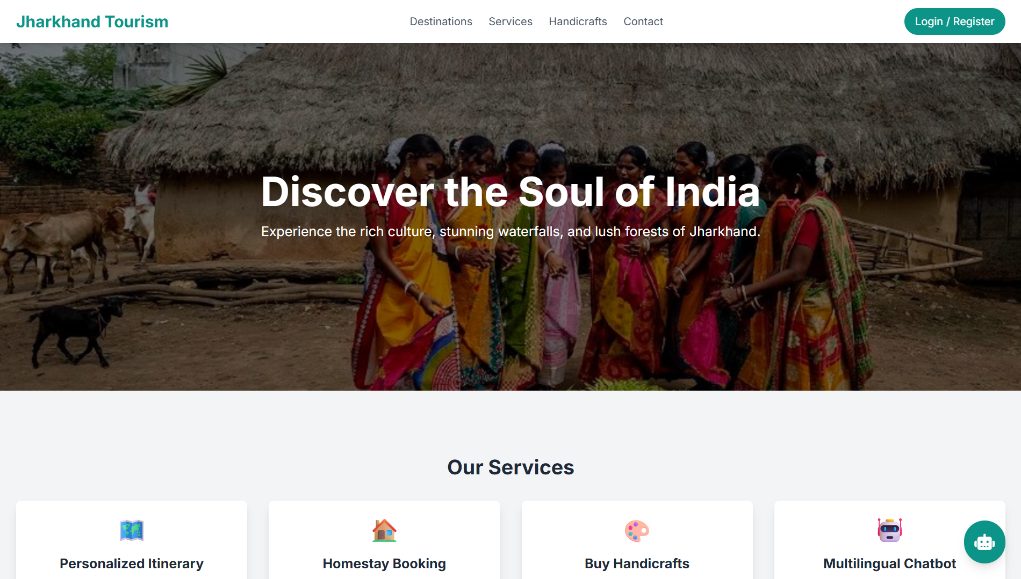
The landing page is the first interface presented to users when accessing the platform. It is designed to create a strong visual impression while providing easy navigation to core functionalities.
The page displays dynamic banners showcasing prominent tourist destinations of Jharkhand such as waterfalls, forests, temples, and tribal heritage locations. A navigation bar is provided at the top, allowing users to access destination listings, guide services, homestays, vendor marketplaces, and the chatbot.A prominently visible SOS emergency button is positioned on the interface to ensure immediate access during critical situations. The chatbot icon is also fixed on the screen, allowing users to initiate interaction at any time. The landing page output confirms that the system successfully attracts users while maintaining clarity and usability.

6.4 User Registration and Login Output

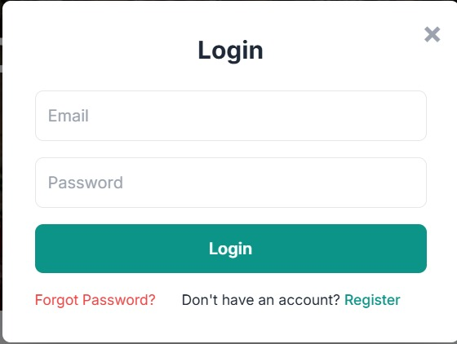
The user registration and login module allows tourists to create personalized accounts on the platform. The registration screen captures essential information such as name, email address, and password.
Upon successful registration, the system stores user details securely in the database and redirects the user to the dashboard or homepage. The login screen verifies credentials and grants access to authenticated users.
The output confirms proper validation of user input, error handling for incorrect credentials, and secure session management. This module ensures personalized access to bookings, reviews, and emergency features.

6.5 Destination Listing Output
The destination listing page presents all available tourist destinations in a structured and visually appealing format. Destinations are displayed using card-based layouts containing images, names, and categories.
Users can filter destinations based on type such as waterfalls, religious sites, eco-tourism spots, or cultural attractions. Each card links to a detailed destination page.
The output demonstrates fast data retrieval and smooth navigation, confirming efficient frontend-backend communication. This module enables tourists to explore Jharkhand comprehensively from a single platform.

6.6 Destination Detail Page Output
The destination detail page provides in-depth information about a selected tourist spot. It includes historical background, geographical location, best visiting season, safety guidelines, nearby attractions, and available services.
Images and descriptive text are displayed clearly, enhancing user understanding. Additional sections show nearby guides, homestays, and vendors associated with the destination.
The output confirms that the system successfully aggregates multiple data sources into a single informative interface, improving decision-making for tourists.

6.7 AI Chatbot Output Description
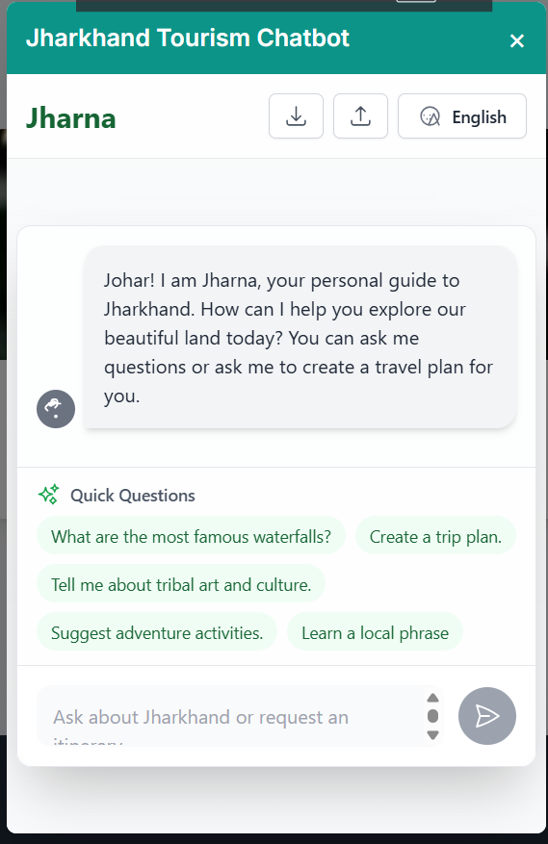

The AI chatbot acts as a virtual travel assistant available throughout the platform. When users interact with the chatbot, they can ask questions related to destinations, itineraries, safety advice, cultural practices, and travel planning.
The chatbot processes natural language queries and provides context-aware responses generated using the Google Gemini API. Responses are accurate, conversational, and informative.
The output confirms that the chatbot can handle diverse queries, generate personalized recommendations, and provide real-time assistance. This module significantly enhances user engagement and reduces dependency on manual support.

6.8 Guide Booking Output
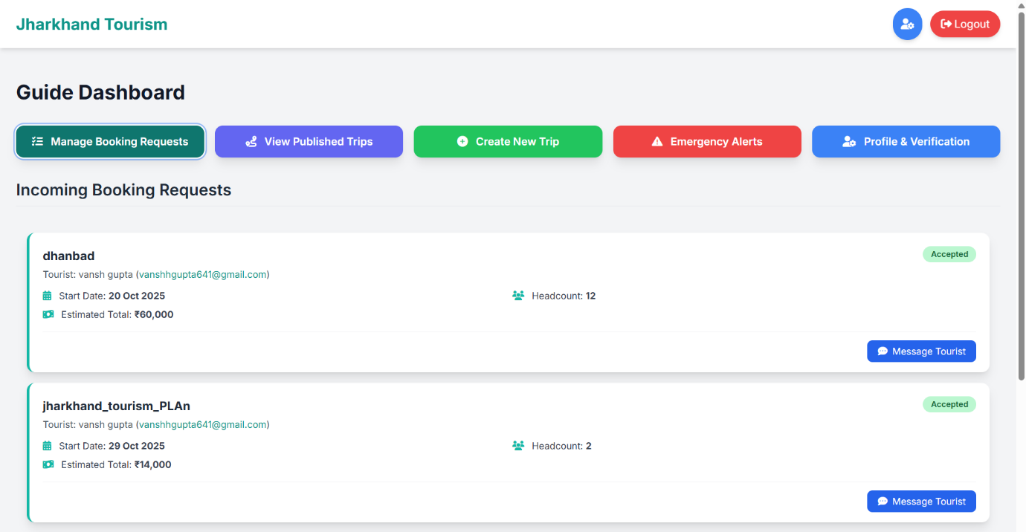
The guide booking module allows users to browse verified local guides and request their services. Guide profiles display information such as experience, specialization, languages spoken, ratings, and availability.
Users can send booking requests directly through the platform. Upon acceptance by the guide, confirmation is displayed to the user.
The output demonstrates transparent interaction between tourists and guides, promoting trust and authenticity. This module successfully bridges the gap between visitors and local experts.

6.9 Homestay Booking Output
The homestay module enables tourists to explore accommodation options managed by local residents. Homestay profiles include amenities, pricing, images, availability, and ratings.
Users can send booking requests and receive confirmation notifications. The system updates availability status accordingly.The output confirms seamless booking workflow and promotes community-based tourism by directly connecting tourists with local homestay owners.

6.10 Vendor and Artisan Marketplace Output
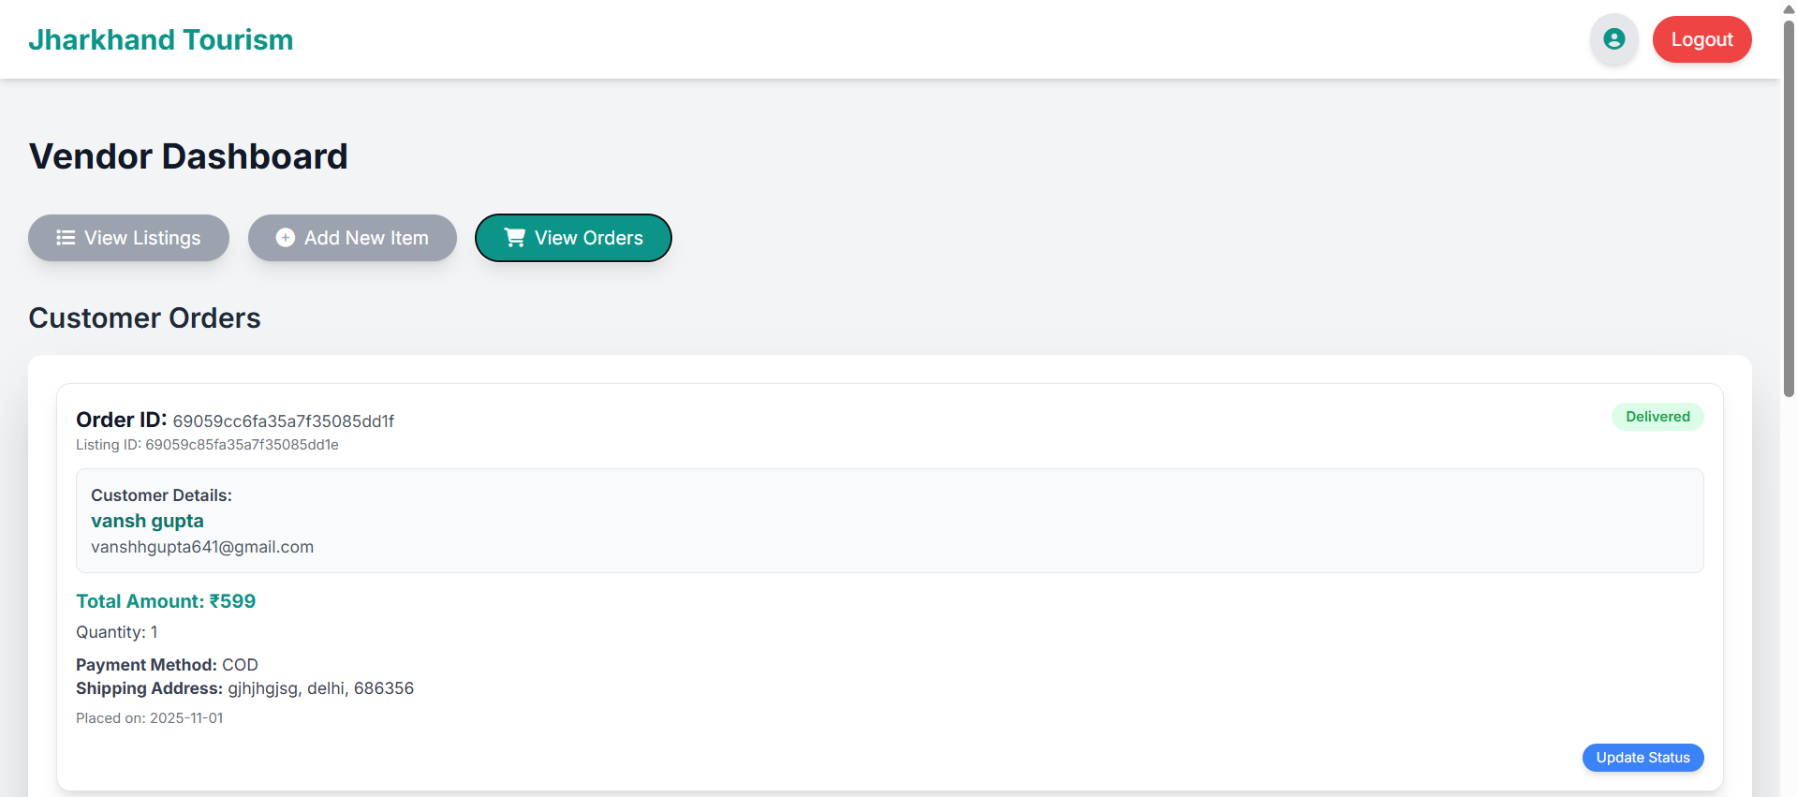
The vendor marketplace showcases local artisans, handicraft sellers, and service providers. Product listings include descriptions, images, prices, and seller ratings.
Tourists can browse products and contact vendors directly. This output highlights the system’s role in digitally empowering local communities and preserving tribal art and culture.
The marketplace output demonstrates transparency, accessibility, and fair exposure for local vendors.

6.11 SOS Emergency Interface Output
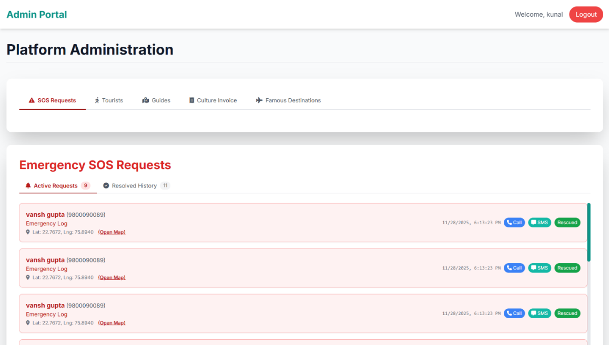

The SOS emergency module is one of the most critical components of the system. When activated, the interface displays emergency instructions, user location status, and alert confirmation.
The system captures real-time geolocation data and sends alerts to nearby responders such as police, medical services, and verified guides. A cancellation option is provided to prevent accidental triggers.
The output confirms rapid alert processing and reliable emergency handling, significantly improving tourist safety in remote areas.

6.12 Admin Dashboard Output
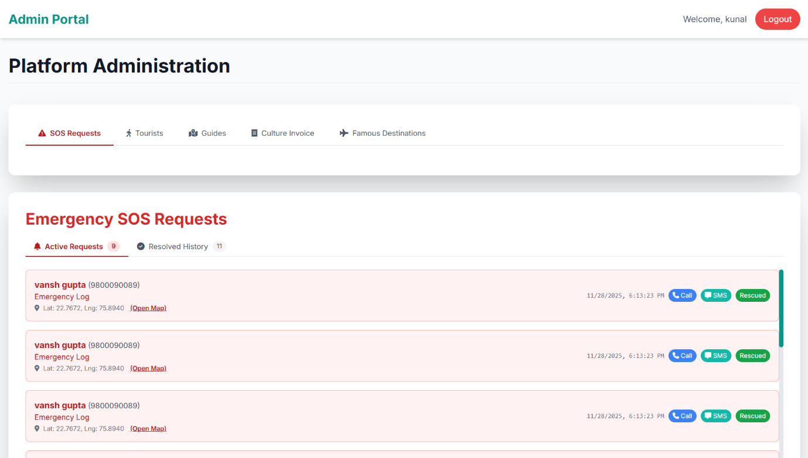

The admin dashboard provides a centralized interface for system administrators. It displays system statistics, user registrations, pending verifications, SOS alerts, and content management options.
Administrators can approve or reject guide, vendor, and homestay registrations. Active SOS alerts are highlighted for immediate attention.
The output demonstrates effective system governance, data control, and monitoring capabilities.

6.13 Performance Analysis Results
Performance evaluation indicates that the system responds efficiently to user interactions. Page load times are minimal, and chatbot responses are generated within acceptable latency.
The system maintains stability under multiple simultaneous user actions, confirming robustness of backend implementation.

6.14 User Experience Evaluation
User experience analysis shows that the platform is easy to navigate, visually appealing, and informative. Clear layouts, readable text, and intuitive controls enhance usability.
The continuous availability of chatbot and SOS features improves confidence and trust among users.

6.15 Limitations Observed During Testing
Some limitations were observed during testing. AI responses depend on internet connectivity and external API availability. Offline functionality is limited.
Integration with real government emergency systems was simulated and not fully implemented due to academic constraints.

6.16 Chapter Summary
This chapter presented a detailed analysis of system results and output screens of the Smart AI-Powered Tourism Platform for Jharkhand. The outputs confirm that the system meets functional and non-functional requirements effectively. Each module operates as intended, providing intelligent assistance, safety mechanisms, and community integration.
The next chapter concludes the project and discusses future enhancement possibilities.

CHAPTER 7

CONCLUSION & FUTURE SCOPE

7.1 Introduction
This chapter presents the final conclusions drawn from the design, development, and evaluation of the Smart AI-Powered Tourism Platform for Jharkhand. It summarizes the achievements of the project, highlights its contributions to the tourism and technology domains, and reflects on how the system addresses the problems identified at the beginning of the study. Additionally, the chapter outlines future enhancements and expansion possibilities that can further improve the system’s effectiveness, scalability, and real-world applicability.

7.2 Project Summary
The Smart AI-Powered Tourism Platform for Jharkhand was conceived as a response to the lack of a centralized, intelligent, and user-centric digital tourism system for the state. Jharkhand possesses immense natural, cultural, and ecological wealth, yet remains underexplored due to fragmented information sources, lack of verified services, and limited safety support.
Throughout the project, a comprehensive system was designed and implemented to bridge this gap. The platform integrates destination discovery, AI-based guidance, local guide and homestay booking, vendor and artisan marketplaces, emergency SOS support, and administrative monitoring into a single unified ecosystem. Modern web technologies, database management systems, and artificial intelligence tools were effectively combined to deliver a practical and innovative solution.

7.3 Achievement of Objectives
The primary objectives defined during the initial phase of the project have been successfully achieved. A centralized digital platform was developed that provides comprehensive and reliable tourism information for Jharkhand. Tourists can explore destinations, understand cultural significance, plan itineraries, and access safety guidelines through a single interface.
The integration of an AI-powered chatbot using Google Gemini API fulfills the objective of providing intelligent, conversational assistance. The chatbot enables real-time interaction, personalized recommendations, and contextual responses, enhancing user engagement and satisfaction.
The SOS emergency assistance system meets the safety objective by enabling tourists to request help instantly during emergencies. This feature is particularly important for remote and forested regions of Jharkhand, where access to help may otherwise be delayed.
The project also achieves the goal of empowering local communities by providing digital visibility to guides, homestay owners, vendors, and artisans. Transparent rating and review mechanisms further enhance trust and service quality.

7.4 Technical Contributions
From a technical perspective, the project demonstrates the effective application of full-stack web development principles. The use of HTML, CSS, and JavaScript ensures a responsive and user-friendly frontend, while Node.js and Express.js provide a scalable backend framework.
MongoDB enables flexible data storage suitable for heterogeneous tourism data. The integration of AI through the Gemini API showcases practical usage of natural language processing and conversational AI in a real-world application.
The modular architecture adopted in the system allows independent development, testing, and future expansion of components. This design approach enhances maintainability and scalability, making the system suitable for long-term deployment.

7.5 Social and Economic Impact
Beyond technical achievements, the project has significant social and economic implications. By directly connecting tourists with local guides, artisans, and homestay owners, the platform promotes inclusive growth and community participation in tourism.
The system encourages sustainable tourism practices by highlighting eco-sensitive zones, promoting responsible travel behavior, and supporting local livelihoods. Increased digital visibility can lead to improved income opportunities for rural and tribal communities.
The safety features implemented in the system also contribute to social welfare by reducing travel-related risks and improving tourist confidence in exploring lesser-known regions.

7.6 Limitations of the Project
Despite its successful implementation, the project has certain limitations. Real-time integration with official government emergency services was simulated and not fully deployed due to academic constraints.
The AI chatbot’s performance depends on continuous internet connectivity and availability of external APIs. Offline access to AI-based features is currently limited.
Advanced security features such as multi-factor authentication and encryption at rest were not implemented due to scope limitations but can be added in future versions.

7.7 Future Scope
The Smart AI-Powered Tourism Platform offers extensive opportunities for future enhancement and expansion. Several potential improvements are identified below.
One major enhancement is the development of a dedicated mobile application using cross-platform frameworks such as Flutter or React Native. A mobile app would improve accessibility, support push notifications, and enable partial offline functionality.
The AI chatbot can be extended into a voice-based virtual assistant, allowing hands-free interaction for tourists during travel. This feature would be particularly useful for navigation and emergency situations.
Integration of augmented reality and virtual reality technologies can enable virtual tours of destinations, helping tourists explore locations before visiting them physically. This can also be used for educational and promotional purposes.
Real-time weather updates and disaster alerts can be integrated to provide dynamic safety warnings related to floods, landslides, or forest conditions.
A tourist community forum can be introduced to allow users to share experiences, itineraries, reviews, and travel tips, fostering a collaborative tourism ecosystem.
Official integration with government tourism departments and emergency services can transform the platform into an authorized state-level tourism system.
IoT-based SOS devices such as wearable trackers can further enhance safety for trekkers, wildlife photographers, and adventure tourists.

7.8 Learning Outcomes
This project provided valuable learning opportunities across multiple domains. It enhanced understanding of software engineering principles, system design, and project management.
Hands-on experience with full-stack development, database modeling, and AI integration strengthened practical technical skills. The project also improved problem-solving, planning, and documentation abilities.
Additionally, the project highlighted the importance of technology-driven solutions for social development and sustainable growth.

7.9 Final Conclusion
In conclusion, the Smart AI-Powered Tourism Platform for Jharkhand successfully demonstrates how modern digital technologies can transform tourism experiences while promoting safety, sustainability, and community empowerment. The project meets academic objectives and offers real-world applicability with significant potential for future expansion.
By combining intelligent assistance, secure system design, and local service integration, the platform stands as a comprehensive digital solution for Jharkhand tourism. With further enhancements and official support, it can evolve into a fully operational and impactful tourism ecosystem.

APPENDIX

Appendix A

Sample Database Schemas (MongoDB)
This appendix presents representative database structures used in the Smart AI-Powered Tourism Platform for Jharkhand. The schemas are designed using MongoDB due to its flexibility, scalability, and suitability for handling semi-structured tourism data.

A.1 Destination Collection
The destination collection stores detailed information related to tourist locations across Jharkhand. Each document represents a unique destination and includes metadata required for travel planning and safety guidance.
{
"_id": "dest001",
"name": "Hundru Falls",
"category": "Waterfall",
"location": {
"latitude": 23.4567,
"longitude": 85.3214
},
"description": "Hundru Falls is one of the highest waterfalls in Jharkhand and a popular eco-tourism destination.",
"bestSeason": "July to February",
"entryFee": 20,
"safetyLevel": "Moderate",
"safetyTips": [
"Avoid slippery rocks during monsoon",
"Follow marked trails",
"Do not venture close to water edges"
],
"nearbyGuides": ["guide01", "guide02"],
"nearbyHomestays": ["home01", "home02"],
"images": ["hundru1.jpg", "hundru2.jpg"]
}

A.2 User Collection
This collection stores information related to tourists and registered users of the platform.
{
"_id": "user234",
"name": "Kunal Pal",
"email": "user@example.com",
"role": "tourist",
"bookingHistory": ["book01", "book02"],
"reviews": ["rev01", "rev02"],
"emergencyContact": "+91XXXXXXXXXX",
"createdAt": "2025-01-10"
}

A.3 Guide Collection
The guide collection stores verified information about local tour guides.
{
"_id": "guide01",
"name": "Ramesh Kumar",
"experience": 5,
"languages": ["Hindi", "English"],
"specialization": "Forest Trekking",
"verified": true,
"rating": 4.8,
"availability": true,
"assignedDestinations": ["dest001"]
}

A.4 Vendor Collection
This collection maintains details of local artisans and service providers.
{
"_id": "vendor01",
"name": "Tribal Handicraft Seller",
"category": "Art and Craft",
"products": [
"Handmade bamboo basket",
"Traditional tribal jewellery"
],
"location": "Ranchi",
"rating": 4.5,
"verified": true
}

A.5 Homestay Collection
{
"_id": "home01",
"ownerName": "Sita Devi",
"location": "Near Hundru Falls",
"pricePerNight": 1200,
"amenities": ["Food", "WiFi", "Parking"],
"availability": true,
"rating": 4.6
}

A.6 SOS Alert Collection
{
"_id": "sos001",
"userId": "user234",
"location": {
"latitude": 23.4601,
"longitude": 85.2204
},
"timestamp": "2025-01-10T10:35:00",
"status": "Active",
"responders": ["police01", "guide04"]
}

Appendix B

API Endpoints Description
This section describes major RESTful APIs implemented in the system.
API Endpoint | Method | Description
/api/login | POST | User authentication
/api/register | POST | User registration
/api/destinations | GET | Fetch all destinations
/api/chatbot | POST | AI chatbot interaction
/api/sos | POST | Trigger SOS emergency
/api/admin/verify | PUT | Admin verification

Appendix C

System Workflow Descriptions

C.1 Booking Workflow
- User selects guide or homestay
- Booking request sent to backend
- Provider receives request
- Acceptance or rejection
- Confirmation displayed to user

C.2 AI Chatbot Workflow
User Query → Context Builder → Gemini API → Response Processing → User Interface

C.3 SOS Emergency Workflow
SOS Trigger → Location Capture → Responder Identification → Alert Dispatch → Status Monitoring

Appendix D

UML Diagram Description Summary
The UML diagrams used in this project include:
- Use Case Diagram
- Class Diagram
- Sequence Diagram
- Activity Diagram
- Data Flow Diagram
Each diagram contributes to visualizing system structure and interaction flow.

BIBLIOGRAPHY

The following books, research papers, and online resources were referred during the design and development of the Smart AI-Powered Tourism Platform for Jharkhand. These references provided theoretical foundation, technical guidance, and contextual understanding.

- Pressman, R. S., Software Engineering: A Practitioner’s Approach, 8th Edition, McGraw-Hill Education, 2015.
- Sommerville, I., Software Engineering, 10th Edition, Pearson Education, 2016.
- W3C, HTML5 Specification, World Wide Web Consortium.
- Duckett, J., HTML and CSS: Design and Build Websites, Wiley Publishing, 2014.
- Flanagan, D., JavaScript: The Definitive Guide, O’Reilly Media, 2020.
- MongoDB Inc., MongoDB Documentation, Official Developer Guide.
- Node.js Foundation, Node.js Official Documentation.
- Google Cloud, Gemini API Documentation, Google AI Platform.
- Jurafsky, D., and Martin, J., Speech and Language Processing, Pearson Education.
- Buhalis, D., “Technology in Tourism: From Information to Experience,” Tourism Management Journal, Elsevier.
- TripAdvisor Official Website – Review and tourism platform analysis.
- Incredible India Official Tourism Portal.
- Government of Jharkhand Tourism Website.
- IEEE Xplore Digital Library – Research papers on AI in tourism.
- Research articles on smart tourism systems and digital marketplaces.

